Grade 4 Supply Checkoff List
Dear 4th Grade Parents/Guardians,
Welcome to a new school year! We hope this year will be full of new and exciting experiences. The following is a list of supplies your child will need to start the 2025-2026 school year. All other supplies will be provided by the school. Please have your child bring their supplies on their grades assigned date.
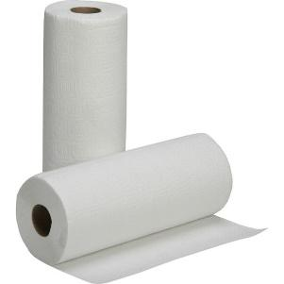
- Personal Items:
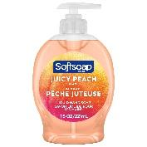
- book bag
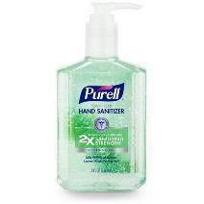
- lunchbox
- Cleaning/Organizational Supplies:
- 1 bottle of hand soap
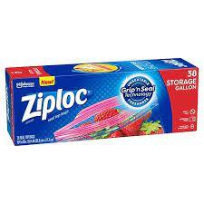
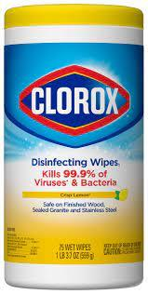
- 1 bottle of hand sanitizer
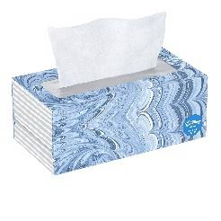
- 1 rolls of paper towels
- 2 boxes of tissues
- 1 pack of baby wipes
- 1 box of Ziploc bags
- 1 pack of Clorox Wipes
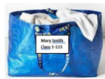
Reminders:
- Please label school supplies with your child’s FIRST and LAST name ONLY.
- Please drop off supplies on your child’s grades drop off day on August 26th OR August 27th from 9:00 AM - 1:00 PM
- LABEL ALL BAGS WITH YOUR CHILD'S NAME AND CLASS

Thank you for your cooperation. We are looking forward to a wonderful year with your child!

